Recently BBAUV found a competitor information,….

Recently I have been involved in an Autonomous Underwater Vehicles competition(The Singapore Autonomous Underwater Vehicles Competition) organised by the IEEE OES Singapore Charter(You can find the website [here](http://ewh.ieee.org/r10/singapore/oes/sauvc/)) which will last until next year March-April 2013. We are still in the conceptualising phase (been here for a month at least already actually) and I shall be blogging about our development thus far! Normally you don’t really blog about your strategies online for fear of competitor copycats, but I guess for all of us we were more into the fun and joy of learning and the experience of developing an Autonomous embedded system and something state of the art!

**The brain of the AUV**

[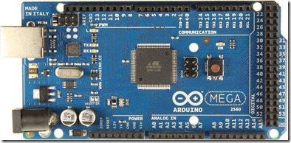](http://lh6.ggpht.com/-CfZPPIMmd0I/UEYliuxtX8I/AAAAAAAAMus/Dta2r1GSmeY/s1600-h/ArduinoMega2560_R3_Front%255B5%255D.jpg) [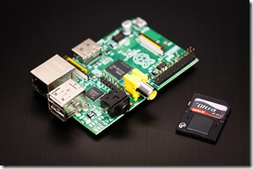](http://lh3.ggpht.com/-c9BetcWU8vI/UEYlkx5ddaI/AAAAAAAAMu0/LWRXbD19O3c/s1600-h/7513051848_9a6ef2feb8_o%255B2%255D.jpg)

The Arduino Mega and the Raspberry Pi

A lot of hype has been going on lately about both embedded boards and we are employing both as the “Thinker” of the entire system with both boards working as parallels. The Arduino Mega(16Mhz) is aimed at low level controls whilst the Raspberry Pi(clocked at 700 MHZ and 256 RAM) is aimed at higher level algorithmic computation and at the same time for more memory intensive processes.

Our project has been further broken up into 5 components currently for each of the 5 team members to focus on a certain discipline before our eventual integration of the platform.

**1. Mechanical Design**

We had been deliberating over this portion for the longest time. And this is the final design that we decided to settle on. Based on current designs in the industry and also some research designs from MIT, we attempted to achieve 6 Degrees of Freedom in this current design though admittedly there maybe some design flaws in the motor positioning. The other mechanical design considerations, such as bouyancy, will be made by our Mechanical engineer, Devansh.

[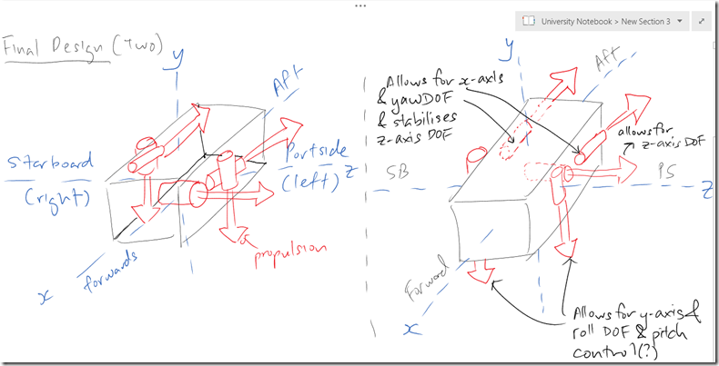](http://lh3.ggpht.com/-1ZfSlWopJRc/UEYlmoCK36I/AAAAAAAAMtc/hVpsER9ojFs/s1600-h/discussion_AUV%255B20%255D.png)

The finalised two designs for our propulsion.

**2. Control and Localisation**

The AUV will be equipped with an Inertial Measurement Unit and Autopilot, the ArduPilot Mega which is a fully fledged Autopilot solution by [Diydrones](http://diydrones.com/) which is perfect for our application given how established their Ardupilot code is on top of a nifty configuration and programming software that they have called Mission Planner. The APM 2.0 is also actually also based on the Atmega 2560. There is also a possibility that I may directly interface the APM 2.0 with the Raspberry Pi instead if all low level controls can actually be handled by the APM 2.0. This reduces an additional piece of hardware and software complexity. The control system will most probably be the Proportional Integral Derivative Feedback Controller and Localisation algorithms I am still in the midst of research for dead reckoning techniques and maybe the Monte Carlo Localisation algorithm.

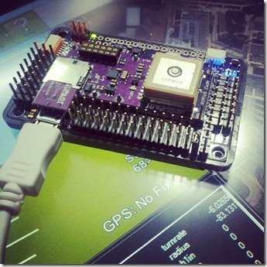

The Ardupilot Mega 2.0

**3. Obstacle Detection/Depth Detection**

This was another major problem we faced as we had to be able to detect both the gate obstacle and the single pole flare which we had to bump. One idea we came up with was to make use of the analog envelope of Sonar to range in to the flare and then once we had acquired the flare with the camera, we would then zoom into targeting the flare, at the same time Sonar would keep track of it’s distance to the flare to ensure that we hit it right on target.

[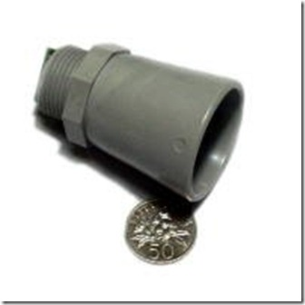](http://lh6.ggpht.com/-dl0SgaABttA/UEYlqrE5KQI/AAAAAAAAMt8/gc9eJIkXhjI/s1600-h/product_image_260_634%25255B3%25255D.jpg)

IP67 rated Sonar from Maxbotix

Depth Detection we are considering either Sonar or the use of this cheap Laser Rangefinder from Parallax. Depth detection is required in sensing how far we are from the floor of the swimming pool whilst following the path.

[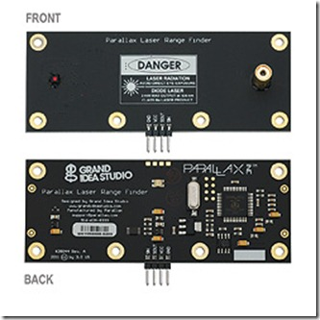](http://lh4.ggpht.com/-9iiaV0hGzZE/UEYlsb_YsLI/AAAAAAAAMuI/q1Xht_2rTik/s1600-h/28044a-M%25255B3%25255D.jpg)

Laser Rangefinder from Parallax

**4. Computer Vision**

We are still considering between TTL Serial JPEG cameras and USB PS3 Cameras but nevertheless the camera will be interfaced with the Raspberry Pi and perform edge detection to follow the black path on the floor of the swimming pool. Additionally the camera will be mounted on a servo and rotation to the forwards position to detect the flare when necessary.

[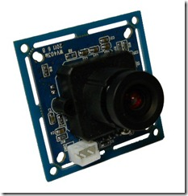](http://lh6.ggpht.com/-tFogzq8YBrU/UEYluE2boBI/AAAAAAAAMuc/jS2sdYq58oo/s1600-h/3-3V-High-Speed-Serial-JPEG-Camera-Module-RS232-or-TTL-level-%25255B2%25255D.jpg)

Serial TTL JPEG Camera

I guess now another crucial decisive point is also our Sponsors. We have thus far been rather unlucky with getting any prospective Company willing to sponsor our endeavour. But ah well, lets hope we would be able to get one soon!

# [Autonomous Underwater Vehicle Development Updates](http://www.iamgew.com/2012/09/autonomous-underwater-vehicle.html)

A lot has been going on these few weeks and I have been trying hard to juggle my academics (Which are largely related to my projects except for Computer Security), my Final Year Project and the AUV Project. So this post is more for updates to our AUV project and our team has been making much research and heavy discussions lately and there have been quite a bit of changes to our initial plans.

**Software and Hardware Architecture**

[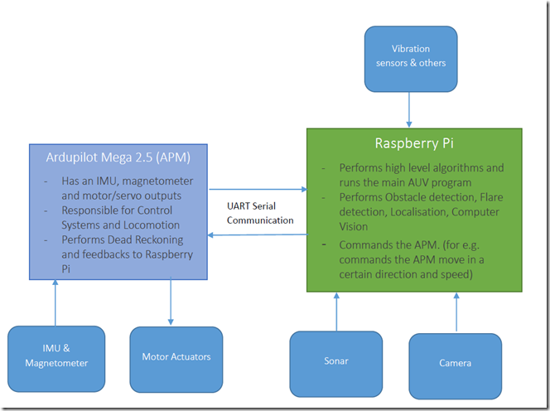](http://lh6.ggpht.com/-RcXqMdlnNmA/UFQ4FxVqxgI/AAAAAAAANDI/qyBDGnKnEZU/s1600-h/image%25255B3%25255D.png)

Our previous discussion points had us utilising the APM, the Arduino Mega and the Raspberry Pi dedicated to camera vision. But upon further discussions with our supervising prof and some research we decided to remove the Arduino Mega and the loop and emplace the Raspberry Pi as the central “Brain” for the AUV and with the Ardupilot Mega as the Slave controller. As noted in the diagram above, the Pi will have the main AUV program running with the Sonar, Camera and vibration sensors connected to it. It will also command the APM to manoeuvre the craft as well as receive localisation information from the APM. The APM will be responsible for the control systems, locomotion and will perform dead reckoning for the AUV since the IMU and motor actuators will be directly interfaced to it. The only downside is we would not be utilising the radio control capability. The APM and the Pi will communicate serially via UART.

**Mechanical Design**

It’s quite funny how after going one big round from 4 motors to 5 motors and then 6 motors and back to 5 motors we eventually settled for a 4 motor design after seeing how “Chio” somebody’s AUV design was.

[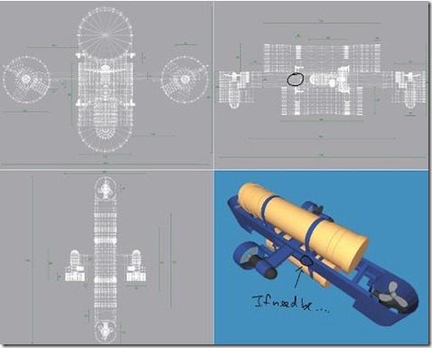](http://lh5.ggpht.com/-G1GlcIEOFfE/UFQ4Hzx1IXI/AAAAAAAANDU/sf2qZIXkwN0/s1600-h/auv_mech%25255B3%25255D.jpg)

The schematic above is extracted from someone’s FYP report in the design of his AUV called the Mako.

Haha of course not! The graphic above is not to illustrate that we were going to copy his design but rather adapt our AUV to have the motor orientation as above. The finalised AUV will have a total of 4 motors, with two thrusters for forward and aft movement and also yaw. The other two motors will control heave/dive and pitch. Roll will be corrected mechanically by a righting moment design as can be seen above with the bottom being heavier than the top ballast. This current design only has 4 Degrees of Freedom with the roll stabilised and the last degree of freedom, i.e. lateral movement was left out as we eventually decided there was no need for it but our ME would provide for the capacity to add one more motor to enable lateral movement which was to drill a hole through the metal frame in the middle. A much neater and simplified design for our needs for the competition I would say.

**Raspberry Pi**

[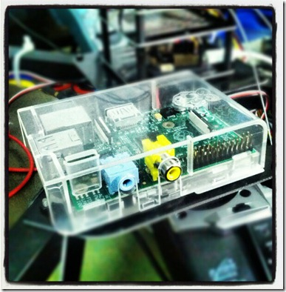](http://lh5.ggpht.com/-_uc4hPcbRB0/UFQ4JnSW-MI/AAAAAAAANDo/SXnKcZ9bIc8/s1600-h/pi%25255B4%25255D.jpg)

I recently received shipment of my Raspberry Pi! Hurray but not after waiting for a few months for it –.- A $45 linux computer is just unbelievable. I have been tinkering with it quite a bit mainly trying to remotely connect to it via SSL and also figure out the best way to code on the Pi with Python since our main source code is probably going to be around it. The –X command for the ssh command is pretty neat too allowing me to run GUI applications, which would otherwise lag like mad if run on the Pi, on a separate machine. What happens is that the commands for the X-server get directed to the X-server of the remote machine instead of utilising the X-server of the Pi which would otherwise lag up the system given the lower processing capability of the ARM11 Chip. The instructions that I got to setting up everything remote can be found [here](http://elinux.org/RPi_Remote_Access#Initial_Setup).

**Control Systems and my UAV**

My piece of the pie (not pi mind you) in the AUV project is to develop the control systems and the Localisation algorithms and I planned to utilise the Arducopter Unmanned Aerial Vehicle(UAV) that I have to actually as realistically as possible test out the effectiveness of my filters (either the Direct Cosine Matrix or the Kalmann filter as recommended in my research) and the dead reckoning algorithms because our Mechanical Engineer, Devansh was still designing and fabricating the vessel. The UAV would be able to simulate better given the intense vibrations from the motors that may affect the APM but unfortunately…

[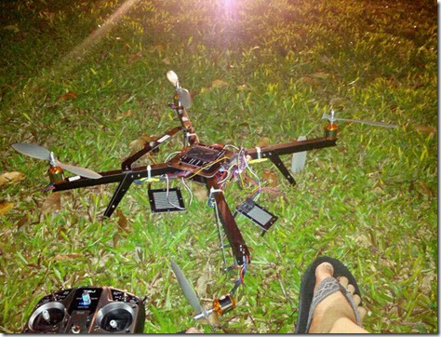](http://lh6.ggpht.com/-Lmv-fix6P9Y/UFQ4LjTTB6I/AAAAAAAAND4/ThZ4hzMzd48/s1600-h/crash%25255B3%25255D.jpg)

the copter flew into me whilst trying to take off in my test runs and crashed badly, injuring myself, damaging a propeller blade, the frame and twisting up the wires of one of the motors real bad as you can see in the picture. I regretted not having gone slower in the test procedures and reading up everything on the flight procedures before flying but I guess it is just all part of the procedure of learning and engineering! In retrospect, it could have been the mechanical build or the control systems(bad Kp,Ki,Kd values for yaw) that led to the uncontrollable spinning of the quadcopter and it’s fateful crash into me! I should have stood further haha then the damage wouldn’t be that bad. I would have to replace the broken parts but for now algorithms testing would be simulated i.e. me holding the APM and “flying” it haha.

[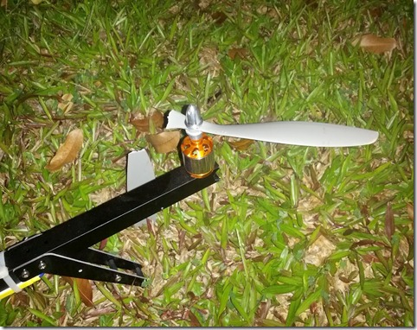](http://lh6.ggpht.com/-HTHxiBAHEk4/UFQ4Nn_rqGI/AAAAAAAANEI/VYKmmA6Zwwc/s1600-h/IMG_20120914_221926%25255B8%25255D.jpg)

[The propeller that broke into two.](http://lh5.ggpht.com/-2N97VAMk8yo/UFQ4Pl0OxsI/AAAAAAAANEY/h8ZJdyKhvdw/s1600-h/IMG_20120914_221941%25255B6%25255D.jpg)

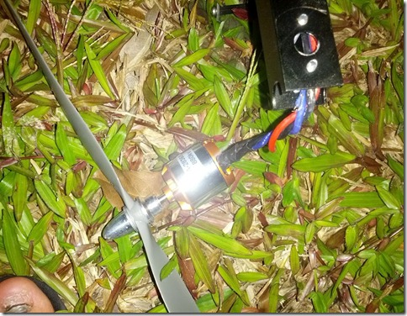

The motor all banged up and the wires twisted.

Posted 2 hours ago by [Goh Eng Wei](https://plus.google.com/105039388603605825371)

Labels: [Hardware](http://www.iamgew.com/search/label/Hardware) [Software](http://www.iamgew.com/search/label/Software)

###### [Goh Eng Wei](http://www.facebook.com/gohengwei) took a photo with [Instagram](http://www.facebook.com/apps/application.php?id=124024574287414&fb_action_ids=10150980759832821&fb_action_types=instapp%3Atake&fb_ref=ogexp&fb_source=og_timeline_photo_robotext).

[August 20](http://www.facebook.com/gohengwei/activity/10150980759832821?og_perm_src=OPEN_GRAPH_SINGLE_STORY)

Finally got to working on the APM 2.0 for my Autonomous Underwater Vehicles project! #Autonomous #AUV #IMU[http://instagr.am/p/OjaU5No_k9/](http://instagr.am/p/OjaU5No_k9/?fb_source=og_timeline_photo_user_message)

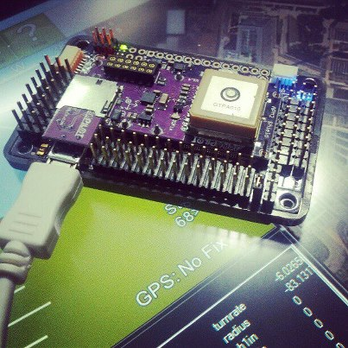

[C:\Users\THANHQ~1\AppData\Local\Temp\enhtmlclip\Image.gif](http://www.facebook.com/gohengwei/app_instapp)[Like](http://www.facebook.com/gohengwei) ·  · [Share](http://www.facebook.com/ajax/sharer/?s=44&appid=2309869772&p%5B0%5D=732337820&p%5B1%5D=10150980759832821)

* [2 people](http://www.facebook.com/browse/likes?id=10150980759857821) like this.
* [C:\Users\THANHQ~1\AppData\Local\Temp\enhtmlclip\Image(12).jpg](http://www.facebook.com/chika.chucker)

[**Chia Kai Bin**](http://www.facebook.com/chika.chucker) nice..wad communication u using from gnd station to bot

[August 20 at 10:50pm](http://www.facebook.com/photo.php?fbid=10150980759857821&set=a.10150945050477821.410530.732337820&type=1&relevant_count=1&comment_id=7079765&offset=0&total_comments=16) · Like

* [C:\Users\THANHQ~1\AppData\Local\Temp\enhtmlclip\Image(13).jpg](http://www.facebook.com/gohengwei)

[**Goh Eng Wei**](http://www.facebook.com/gohengwei) Communication not allowed for the AUV! System has to be fully autonomous

[August 20 at 10:51pm](http://www.facebook.com/photo.php?fbid=10150980759857821&set=a.10150945050477821.410530.732337820&type=1&relevant_count=1&comment_id=7079780&offset=0&total_comments=16) · Like

* [**Chia Kai Bin**](http://www.facebook.com/chika.chucker) fully autonomous..? hmm then u putting 6 axis sensors? u dun even have RC for the initial control?

[August 20 at 10:55pm](http://www.facebook.com/photo.php?fbid=10150980759857821&set=a.10150945050477821.410530.732337820&type=1&relevant_count=1&comment_id=7079799&offset=0&total_comments=16) · Like

* [**Goh Eng Wei**](http://www.facebook.com/gohengwei) But of course for debugging purposes we're considering USB or datalogging. Wireless telemetry or control not really possible given that it gets attenuated upon entering water yeah

[August 20 at 11:06pm](http://www.facebook.com/photo.php?fbid=10150980759857821&set=a.10150945050477821.410530.732337820&type=1&relevant_count=1&comment_id=7079802&offset=0&total_comments=16) · [Edited](http://www.facebook.com/gohengwei) · Like

* [**Chia Kai Bin**](http://www.facebook.com/chika.chucker) ya definitely it's a constrain..wads e job of the AUV?

[August 20 at 10:58pm](http://www.facebook.com/photo.php?fbid=10150980759857821&set=a.10150945050477821.410530.732337820&type=1&relevant_count=1&comment_id=7079816&offset=0&total_comments=16) · Like

* [**Goh Eng Wei**](http://www.facebook.com/gohengwei) yep we got an 6 axis IMU coupled with magnetometers. Got to come up with various artificial intelligence algorithms like dead reckoning, obstacle detection and computer vision to enable to system to have a mind of it's own and navigate it's way in the waters

[August 20 at 10:58pm](http://www.facebook.com/photo.php?fbid=10150980759857821&set=a.10150945050477821.410530.732337820&type=1&relevant_count=1&comment_id=7079818&offset=0&total_comments=16) · Like

* [**Goh Eng Wei**](http://www.facebook.com/gohengwei) primarily it works like a sub or ROV that can help to scout the deep waters for various purposes like marine research, wreckage search and a lot of ongoing research in that field now. Other research studies are for example into swarm AUVs that can cooperatively scan the sea depths in tandem and well military applications defiinitely are too(surveillance?) But ours is a competition to imbue AUV systems engineering experience to participants so the focus is more on systems engineering and autonomous control than practical implementation

[August 20 at 11:02pm](http://www.facebook.com/photo.php?fbid=10150980759857821&set=a.10150945050477821.410530.732337820&type=1&relevant_count=1&comment_id=7079833&offset=0&total_comments=16) · Like

* [**Goh Eng Wei**](http://www.facebook.com/gohengwei) The competition only requires our AUV to operate in swimming pool conditions

[August 20 at 11:03pm](http://www.facebook.com/photo.php?fbid=10150980759857821&set=a.10150945050477821.410530.732337820&type=1&relevant_count=1&comment_id=7079840&offset=0&total_comments=16) · Like

* [**Chia Kai Bin**](http://www.facebook.com/chika.chucker) its quite challenging without minimum control..anyway with APM program, i dun tink you can do all of tt you have mentioned..anyway i believe obstacle sensing can be done..but in water maximum sensing mayb at most 1m..which means it will go quite slowly in water..which affect the size of the batt and then e weight..hmm..hah but its gd n interesting..

[August 20 at 11:08pm](http://www.facebook.com/photo.php?fbid=10150980759857821&set=a.10150945050477821.410530.732337820&type=1&relevant_count=1&comment_id=7079874&offset=0&total_comments=16) · Like

* [**Goh Eng Wei**](http://www.facebook.com/gohengwei) Oh I missed out the closed loop control algorithms, essentially PID (if you did control theory b4), which will enable autonomous control and stabilisation of the vehicle. Haha what do you mean by APM program? Our AUV will consist of three parallel processors, two Atmega 2560 microcontrollers and 1 Raspberry Pi or Gumstix. (still pending which) The raspberry pi or gumstix with more RAM in it is responsible for computer vision, this APM 2.0 has an atmega chip too which handles the IMU and magnetometer readings and lastly our arduino mega is the mother of all, and receives data from the two parallel processing boards and runs the various algorithms.

[August 20 at 11:16pm](http://www.facebook.com/photo.php?fbid=10150980759857821&set=a.10150945050477821.410530.732337820&type=1&relevant_count=1&comment_id=7079933&offset=0&total_comments=16) · Like

* [**Goh Eng Wei**](http://www.facebook.com/gohengwei) we're still searching for the best sensor for underwater depth and obstacle detection and still deciding between LIDAR or SONAR or both! But the good thing is our field is in a swimming pool which helps us eliminate couple of the complications deep sea would present to us

[August 20 at 11:17pm](http://www.facebook.com/photo.php?fbid=10150980759857821&set=a.10150945050477821.410530.732337820&type=1&comment_id=7079937&offset=0&total_comments=16) · Like

* [C:\Users\THANHQ~1\AppData\Local\Temp\enhtmlclip\Image(14).jpg](http://www.facebook.com/zhanwei.lim)

[**Zhan Wei Lim**](http://www.facebook.com/zhanwei.lim) cool! hmm.. with raspberry pi, you might be able to run ROS, which would take care of vision, sensors, and navigation?

[August 21 at 8:36pm](http://www.facebook.com/photo.php?fbid=10150980759857821&set=a.10150945050477821.410530.732337820&type=1&comment_id=7086673&offset=0&total_comments=16) · Like · [1](http://www.facebook.com/browse/likes?id=10150982619377821)

* [**Goh Eng Wei**](http://www.facebook.com/gohengwei) I thought of using pi too to control everything! But upon reading on forum discussions on the APM 2.0 some ppl have reccomended against solely controlling via the Pi due to OS latency issues and interrupt overheads. for e.g. if the control algorithms were to run on the pi it may not be able to correct the system fast enough as per on the atmega microcontroller

[August 27 at 5:19pm](http://www.facebook.com/photo.php?fbid=10150980759857821&set=a.10150945050477821.410530.732337820&type=1&comment_id=7126394&offset=0&total_comments=16) · Like

* [**Goh Eng Wei**](http://www.facebook.com/gohengwei) You have any experience with using ROS?

[August 27 at 5:19pm](http://www.facebook.com/photo.php?fbid=10150980759857821&set=a.10150945050477821.410530.732337820&type=1&comment_id=7126397&offset=0&total_comments=16) · Like

* [**Zhan Wei Lim**](http://www.facebook.com/zhanwei.lim) oh.. yah. Pi with linux is more like a general PC, might not meet the timing required from RTOS. probably need to be complemented by other microcontroller for low level controls. depending on your needs, don't think atmega is capable of running more complex algorithms for nav n recognitions.  
  My only experience with ROS is mainly watching my lab mates playing with robots on ROS. haha. but seems like nowadays there are packages for most common robotic tasks, like navigation n vision.

[August 27 at 6:14pm](http://www.facebook.com/photo.php?fbid=10150980759857821&set=a.10150945050477821.410530.732337820&type=1&relevant_count=1&comment_id=7126527&offset=0&total_comments=16) · Like

* [**Goh Eng Wei**](http://www.facebook.com/gohengwei) hmmm interesting ROS is a software framework based on Ubuntu. We prolly will have to attempt to find a middle ground between low control on the atmega and high level algorithms on the pi! Thanks for your reccomendations!

[August 27 at 6:24pm](http://www.facebook.com/photo.php?fbid=10150980759857821&set=a.10150945050477821.410530.732337820&type=1&relevant_count=1&comment_id=7126564&offset=0&total_comments=16) · Like